Spark SQL in Spark-Shell:

我没有按照word上那样在hdfs上创建一个文件，然后通过文件创建一个内容rdd
虽然word上的是导入文件的一种标准过程，但是我们这里只需要演示大致流程即可，所以我按照对命令的理解，使用了下述命令流：

val recordRDD = sc.parallelize(List(List("0","vega","21")))
case class Person(id:Int, name:String, age:Int)
val personRDD=recordRDD.map(x => Person(x(0).toInt, x(1), x(2).toInt))
val personDF = personRDD.toDF
personDF.show
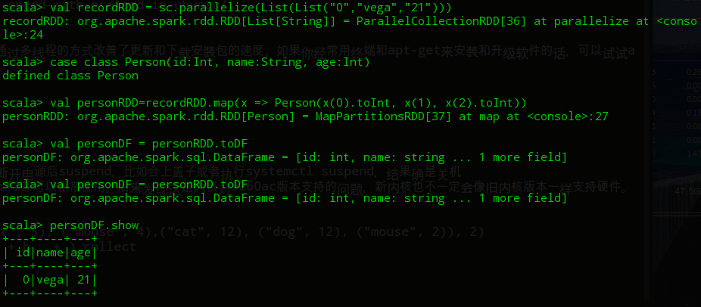

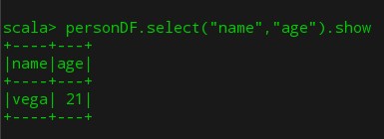

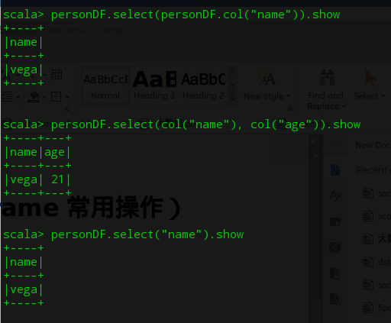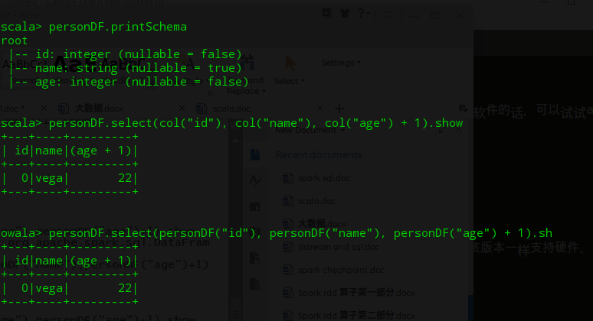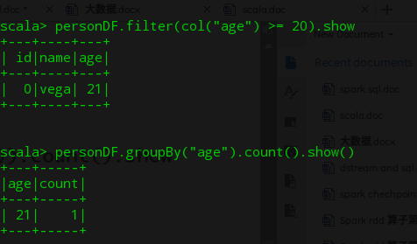

Spark SQL in idea:

通过Person对象的反射推断表结构，关键函数toDF：
import org.apache.spark.{SparkConf, SparkContext}
import org.apache.spark.sql.SparkSession
object SparkSQL {
case class Person(id:Int, name:String, age:Int)
def main(args: Array[String]): Unit = {
val conf = new SparkConf().setMaster("spark://172.18.0.6:7077").setAppName("CheckPoint").setJars(Array("/media/vega/0D6C051A0D6C051A/all/Program/Scala/SparkSQL/out/artifacts/SparkSQL_jar/SparkSQL.jar"))
val sc = new SparkContext(conf)
val sqlContext = SparkSession.builder.config(conf).getOrCreate()
import sqlContext.implicits._
val recordRDD = sc.parallelize(List(List("0","vega","21"),List("1","Battery","21")))
//spark.read.json 也可以从本机读取json数据
val personDF=recordRDD.map(x => Person(x(0).toInt, x(1), x(2).toInt)).toDF()
//将dataframe注册成为临时表
personDF.createOrReplaceTempView("person")
// 使用sql的方式
personDF.show
sqlContext.sql("select * from person where age> 20 order by age desc").show()
sc.stop
}
}
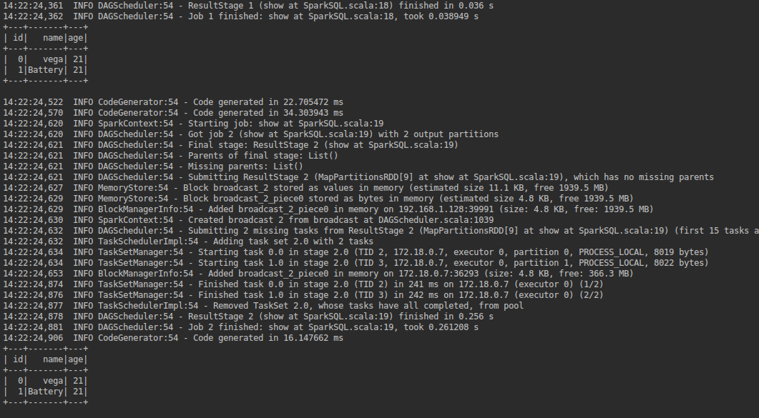

createDataFrame函数也可以通过反射确定schema：
import org.apache.spark.sql.SparkSession
import org.apache.spark.{SparkConf, SparkContext}
object SparkSQL {
case class Person(id:Int, name:String, age:Int)
def main(args: Array[String]): Unit = {
val conf = new SparkConf().setMaster("spark://172.18.0.6:7077").setAppName("CheckPoint").setJars(Array("/media/vega/0D6C051A0D6C051A/all/Program/Scala/SparkSQL/out/artifacts/SparkSQL_jar/SparkSQL.jar"))
val sc = new SparkContext(conf)
val sqlContext = SparkSession.builder.config(conf).getOrCreate()
val recordRDD = sc.parallelize(List(List("0","vega","21"),List("1","Battery","21")))
//spark.read.json 也可以从本机读取json数据
val personRDD=recordRDD.map(x => Person(x(0).toInt, x(1), x(2).toInt))
val personDF = sqlContext.createDataFrame(personRDD)
//将dataframe注册成为临时表
personDF.createOrReplaceTempView("person")
// 使用sql的方式
personDF.show
sqlContext.sql("select * from person where age> 20 order by age desc").show()
sc.stop
}
}

通过StructType指定表结构，结合Row转变：
import org.apache.spark.{SparkConf, SparkContext}
import org.apache.spark.sql.{Row, SparkSession}
import org.apache.spark.sql.types.{IntegerType, StringType, StructField, StructType}
object SparkSQL {
def main(args: Array[String]): Unit = {
val conf = new SparkConf().setMaster("spark://172.18.0.6:7077").setAppName("CheckPoint").setJars(Array("/media/vega/0D6C051A0D6C051A/all/Program/Scala/SparkSQL/out/artifacts/SparkSQL_jar/SparkSQL.jar"))
val sc = new SparkContext(conf)
val sqlContext = SparkSession.builder.config(conf).getOrCreate()
val schema = StructType(List(
StructField("id" , IntegerType , false),
StructField("name" ,StringType,true),
StructField("age" ,IntegerType,true)
))
val recordRDD = sc.parallelize(List(List("0","vega","21"),List("1","Battery","21")))
//spark.read.json 也可以从本机读取json数据
val personRDD=recordRDD.map(x => Row(x(0).toInt , x(1).toString,x(2).toInt))
val personDF = sqlContext.createDataFrame(personRDD,schema)
//将dataframe注册成为临时表
personDF.createOrReplaceTempView("person")
// 使用sql的方式
personDF.show
sqlContext.sql("select * from person where age> 20 order by age desc").show()
sc.stop
}
}
